Name: _________________________________________ Form: 1N
- Measurement is very important in everyday life, name two ways in which we incorporate measurement into our lifestyle (eg. In work, at home, in school) (2)
- _____________________________________________________________________

- _____________________________________________________________________

- There is a need for measurement to be consistent, that is, measurement around the world must be standardized. So scientists from different parts of the world have adopted a single system of units called the SI units. In the missing spaces in the table below fill in the correct SI units and symbol for the physical quantities shown: (10)

Physical Quantity | Symbol for Physical Quantity | SI Unit | Symbol for Unit
Length |  |  | m
Mass |  |  | kg
 | t | second
Temperature |  |  | K
Electric Current |  |  | A

- In measuring physical quantities, specialized equipment is used. Next to each instrument write the name of the instrument as well as the physical quantity which it is used to measure. (The first one is done for you) (10)
ruler length
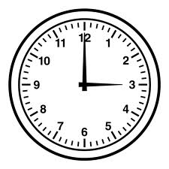
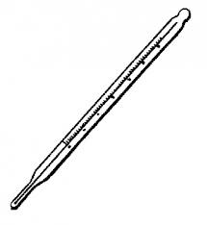

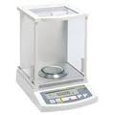

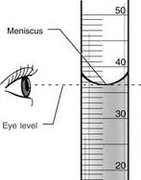
- Joan is learning how to measure using the measuring cylinder, her teacher instructs her
to measure 10mls of water. By looking at the diagram what are some of the precautions
Joan is taking to avoid errors? (3)
- ________________________________________________________________

- ________________________________________________________________

- ________________________________________________________________

- What error is being demonstrated in the diagram below? Circle the correct reading. (2)
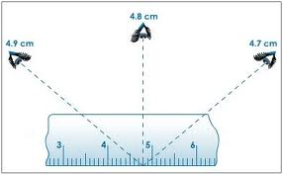Error: _____________________
- Convert the following readings to the units indicated: (10)
(show your working in the blank page opposite)

- 0.75m = _____________cm

- 500g = _____________kg

- 25mg = _____________g

- 25mm = _____________km

- 3 mins = _____________ s

- 1 day = _____________ h = _______________ min = ______________s

- 1kg = ________________ mg

- 4 tonnes = _____________ kg = ___________________g

- 27 ºC = ______________K

- 500K = ______________ºC

